e.times <- faithful$eruptions



short <- e.times[e.times <= 3]

short

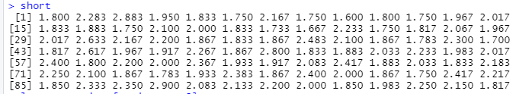

long <- e.times[e.times >- 3]

long

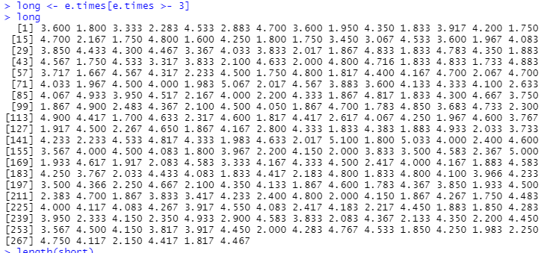

length(short)

length(long)

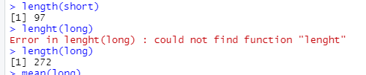

mean(short)

mean(long)



sd(short)

sd(long)



summary(short)

summary(long)

